Artificial Intelligence for Big Data Systems
Assignment 1: Problem Solving by State Space Search
Problem definition:
Given the maze on Fig. 1 (5 x 6 nodes) find a path between the starting node (0.0) and the end node (4,5). The permitted moves are four: Left, Right, Up and Down, the red nodes contain obstacles and no movements in them are possible through them. The boundaries are walls which are blocking the movements.
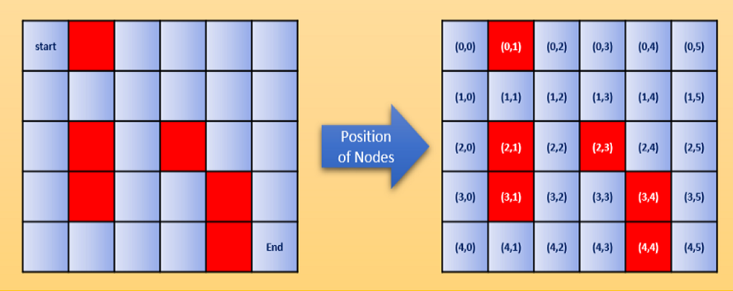
Fig. 1 The Maze Problem
Solution:
To develop a Python program which finds the path from the start node to the end node of the maze and to write a report. The code of the program and the report must be submitted to Moodle by 5 Nov and will be demonstrated during the seminar on 7 Nov.
Group tasks: Max 40 marks
- Chose a suitable representation of the maze nodes using the available Python data
structures.
- Define the success criteria for reaching the end node.
- Define the test function, which accumulates all possible moves for each node
- Define the estimation function to calculate the cost for each move
- Define the path function, which accumulates the past nodes into a path
- Define the cost function, , which accumulates the total cost of the path
- Create an algorithm for search considering the success criteria
- Run the program and output the optimal path found by the algorithm

Additional tasks for individual work max 30 marks
- Implement an alternative algorithm for solving the problem using different method or different heuristic function
- Trace the attempted nodes during the search process
- Visualize the search paths during the execution in 2D plain in graphics mode
- Compare the complexity of the two algorithms in terms of operations and memory
Reports max 30 marks
- The group report must explain the decisions made during the design of the program
and the implementation of the data structures and algorithms in the Python code
- The Individual report must explain the individual work and results
The structure of both reports must correspond to the tasks as specified above.

Deliverables
You need to submit 4 files by the deadline to Moodle
- Group Report and Individual report (pdf)
- Archive file containing the Pythion code for the group part (zip)
- Archive file containing the Pythion code of the additional individual work (zip)
Notes:
- The group tasks are scored max 40% which means that in order to pass it is necessary to have a group report as well (50% is a pass mark)
- The individual tasks are scored max 30% which means that without attempting any of them the mark cannot be a distinction (max 70% where at least 70% is required for distinction)
- The reports are only 30% which means that without code the overall score will be a fail (50% is a pass mark)
- Demonstrating the group work is not marked but without it the entire group code will be discarded, which means no distinction (max 60% where at least 70% is required for distinction)
- Without individual demonstration the code will be discarded and only the group part will be marked (max. 55%, where at least 70% is required for distinction)

